NC Recycling Program

Promotional Item Request Form
Due to popular demand, we have increased the quantity of items you may request.
Please order the supplies needed for the full year.
If you have questions, please contact Mel Gilles at mel.gilles@ncdenr.gov or 919-707-8127.

Name: |  | Pickup at CRA Conference: YES NO, please mail.
Organization: |  | Mailing Address:
Phone Number:
Email Address:
Date Supplies Needed:

IMAGE | DESCRIPTION | MAXIMUM QUANTITY | QUANTITY  REQUESTED
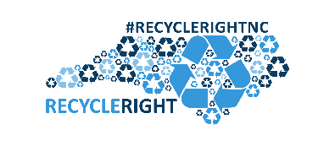 | Recycle Right NC  Stickers | 200
 | Recycle Right NC  Magnet | 30
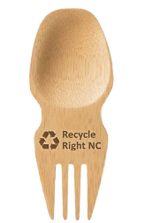 | Recycle Right NC Spork | 10
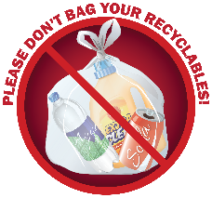 | “Please don’t bag your recyclables” Sticker | 100
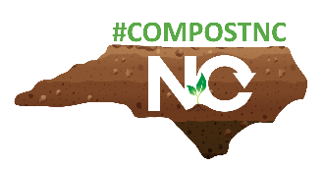 | Compost NC Sticker | 100
 | Recycle More NC Stickers  2.6x6 | 200
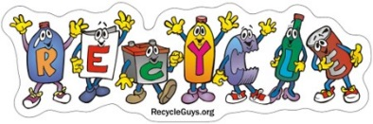 | Recycle Guys Sticker,  8x2.25 inches | 200
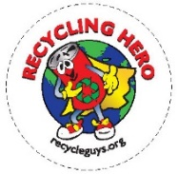 | Born to Recycle Tattoo,  1x1 inch | 500
 | Recycle Guys recycled newsprint pencils | 100
 | RE3.org Keychain / Bottle Opener, various colors | 200
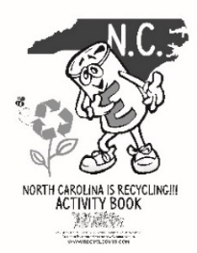 | Recycle Guys Activity Book | 100
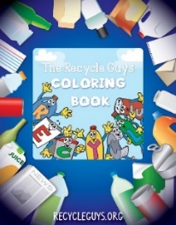 | Recycle Guys Coloring Book | 100
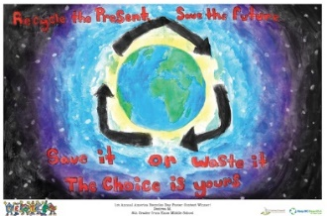 | America Recycles Day Poster Contest Winner 2014,  11x17 inches | 4
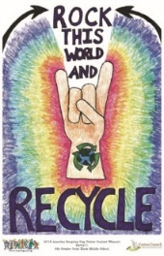 | America Recycles Day Poster Contest Winner 2015,  11x17 inches | 4
 | Recycle Guys Poster,  STAR RECYCLERS,  11x7 inches | 4
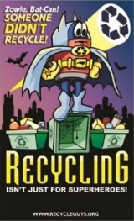 | Recycle Guys Poster,  BAT CAN  11 x 17 inches | 4
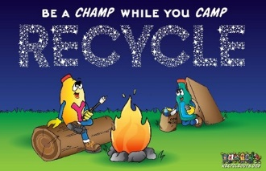 | Recycle Guys Poster,  CAMP  11 x 17 inches | 4
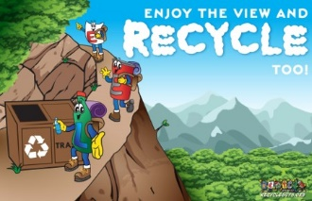 | Recycle Guys Poster,  EXPLORE  11 x 17 inches | 4
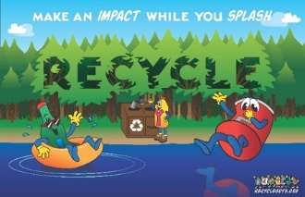 | Recycle Guys Poster,  SWIM  11 x 17 inches | 4

We have more to offer than what you see on this request form!
To find more materials including free graphic design and customized materials, signage, magnets, brochures, and training handouts, please visit: http://www.recyclemorenc.org/

